Order Of Service

Singing: Psalm 45—CW page 83

Reading: Psalm 41

Opening Hymn: TLH 436

Reading: II Corinthians 12:1-13

Request Hymn: CW Supplement 749

Reading: Mark 7:31-37

Sermon Hymn: TLH 605

Sermon Text: Luke 17:28-30

The Days Of Lot

Prayer

The Apostles’ Creed, TLH page 12

Holy Communion

The Lord's Prayer

The Blessing

Closing Hymn: TLH 46

************
Bible Study: Lambs: Kiwi
Sheep: TBA
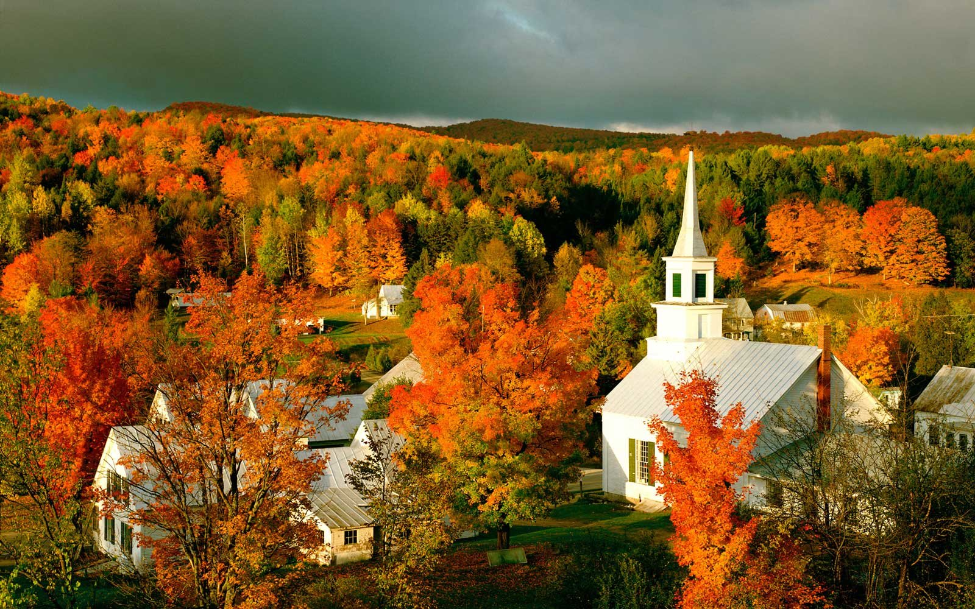

Autumn In Vermont

Water
Of
Life

16 October 2022

W A T E R O F L I F E

Independent Christian Church—Conservative Lutheran Doctrine

Worship Service: 9:30 a.m.

Larry Cooper, Pastor E-Mail address:
111 N. Ridge Road lcooper@wateroflife.cc
Coon Valley, WI 54623 Web Site:
www.wateroflife.cc

* * * * * * * * * * * * * * * * * * * * * * * * * * *

Sermon Text: Luke 17:28-30

The Days Of Lot

* * * * * * * * * * * * * * * * * * * * * * * * * * *

28 Likewise also as it was in the days of Lot; they did eat, they drank, they bought, they sold, they planted, they builded;
29 But the same day that Lot went out of Sodom it rained fire and brimstone from heaven, and destroyed them all.
30 Even thus shall it be in the day when the Son of man is revealed.

